STOCK TRANSPORT ORDER

1. CREATE PURCHASE ORGANIZATION

* PATH : ENTERPRISE STRUCTURE -- DEFINITION –MATERIAL MANAGEMENT – PURCHASE ORG

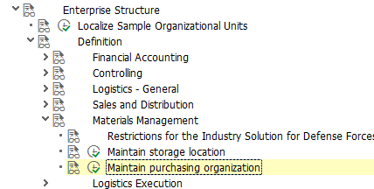

* CREATE A NEW PURCHASING ORG BY COPYING AN EXISTING PURCHASE ORG
* CREATED NEW PURCHASING.ORG (A003)

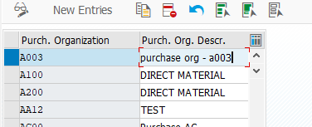

2. CREATE TWO PLANTS (A SUPPLYING PLANT AND A RECEIVING PLANT)

* PATH: ENTERPRISE STRUCTURE -- DEFINITION – LOGISTICS GENERAL – PLANT

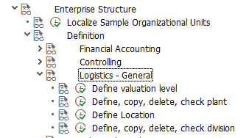

* COPY AN EXISTING PLANT AND CREATE A NEW PLANT

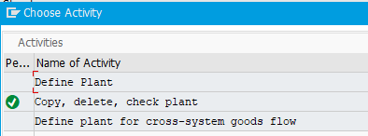

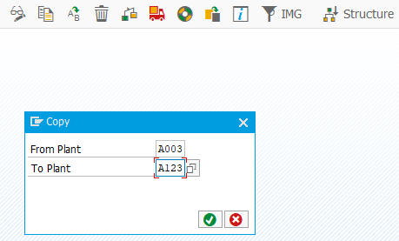

* HERE, I COPIED FROM AN EXISTING PLANT A003 TO A NEW A123 PLANT WHICH WILL BE THE SUPPLYING PLANT IN THIS STO
* ALSO,CREATED RECEIVING PLANT A456 USING THE SAME METHOD MENTIONED ABOVE

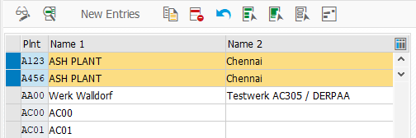

3. CREATE A SHIPPING POINT

* PATH : ENTERPRISE STRUCTURE – DEFINITION – LOGISTICS EXECUTION

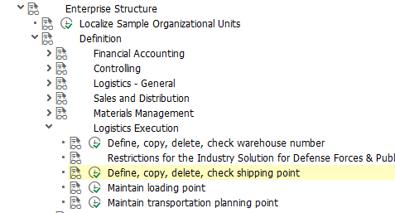

* HERE,I CREATED SHIPPING POINT BY COPYING AN EXISTING SHIPPING POINT
* CREATED SHIPPING POINT (A003)

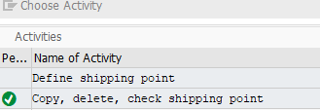

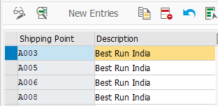

4. LINK CREATED SUPPLYING AND RECEIVING PLANT WITH SHIPPING POINT

* PATH : ENTERPRISES STRUCTURE – ASSIGNMENT -- LOGISTICS EXECUTION – ASSIGN SHIPPING POINT TO PLANT

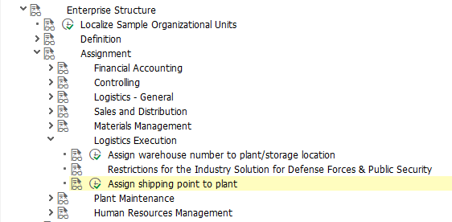

5. CREATE A CUSTOMER AND LINK A VENDOR IN CONTROL DATA :

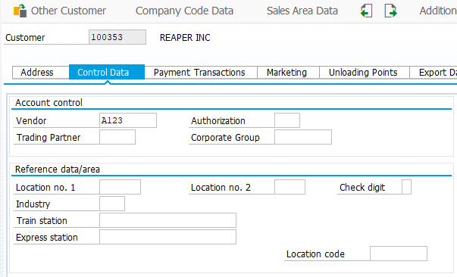

* CREATED CUSTOMER 100353 AND LINKED VENDOR A123

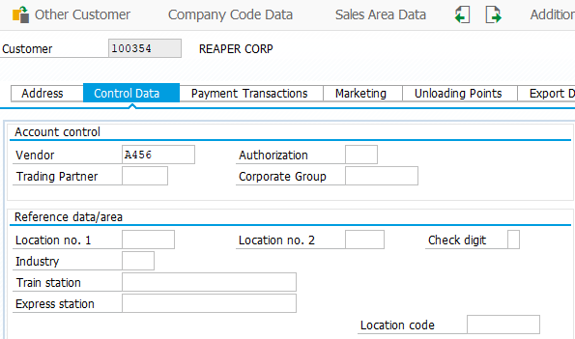

* CREATED ANOTHER CUSTOMER 100354 AND LINKED WITH VENDOR A456.

6. CREATE A VENDOR WITH T.CODE (XK01) AND LINK WITH CUSTOMER

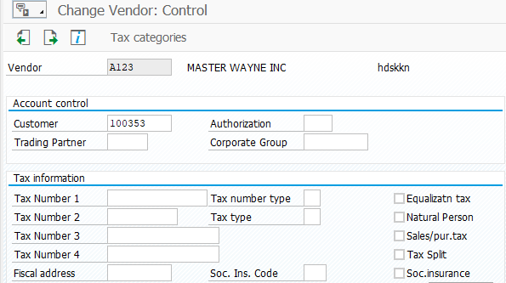

* CREATED VENDOR A123 LINKED WITH CUSTOMER 100353

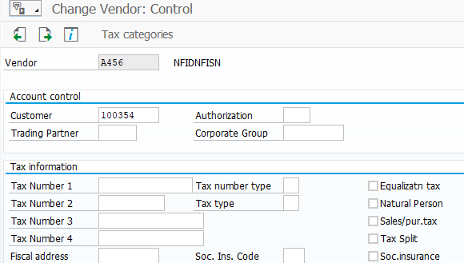

* CREATED VENDOR A456 AND LINKED WITH CUSTOMER 100354

7. EXTEND MATERIAL FROM SUPPLYING PLANT TO RECEIVING PLANT

* THIS CAN BE DONE USING T CODE MM01
* HERE,I EXTENDED MATERIAL 33 FROM PLANT A123 TO A456

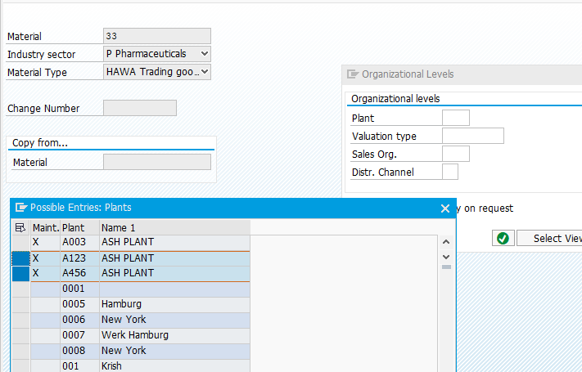

8. CONFIGURATION OF STO

* PATH:
* MATERIAL MANAGEMENT – PURCHASING – PURCHAE ORDER – SET UP STO

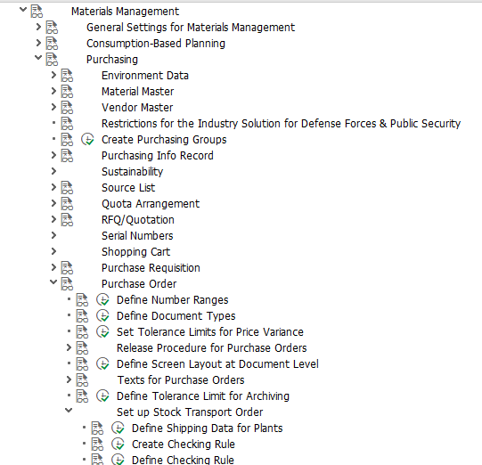

* DEFINE SHIPPING POINT

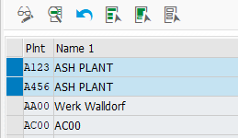

* FOR BOTH PLANTS A123 AND A456 HAVE TO ASSIGN THE EXACT CUSTOMER

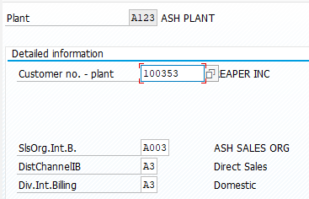

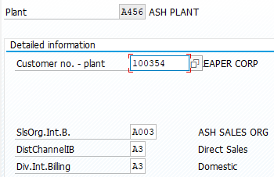

* GO TO ASSIGN DELIVERY TYPE AND CHECKING RULE

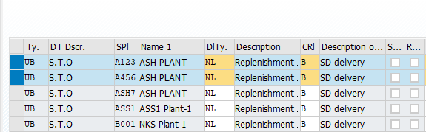

* ASSIGN PURCHASE DOC TYPE UB TO DELIVERY TYPE NL ALONG WITH SUPPLYING PLANT
* GO TO ASSIGN DOCUMENT TYPE,ONE STEP PROCEDURE

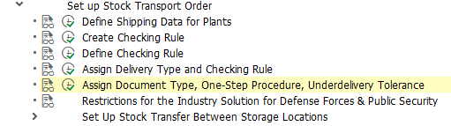

* ENTER SUPPLYING AND RECEIVING PLANT AND ASSIGN THEM TO DOCUMENT TYPE (UB)

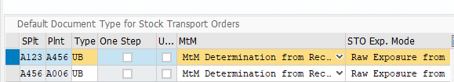

* ONE STEP PROCEDURE: THE GOODS RECEIPT IS POSTED IN THE RECEIVING PLANT AT THE SAME TIME AS THE GOODS ISSUE IS POSTED IN THE ISSING PLANT USING SINGLE MOVEMENT TYPE 301.
* TWO STEP PROCEDURE: STOCK UPDATION TAKES PLACE AT SUPPLYING AND RECEIVING PLANT USING TWO DIFFERENT MOVEMENT TYPE 303 (TO REMOVE STOCK FROM ONE PLANT 1) AND 305 (POST STOCK TO PLANT 2)

ONE STEP PROCEDURE:

* I WILL TRANSFER 10 QTY’S FROM PLANT A123 TO A456 WITH SAME STORAGE LOCATION A003 WITH SAME COMPANY CODE A003
* MATERIAL IS 33 AND WE CAN SEE THAT IN STOCK OVERVIEW USING T. CODE MMBE
* THE QUANTITY’S BEFORE TRANSFERRING FROM PLANT A123 TO A456 ARE AS FOLLOWS:
* STOCK IN PLANT A123:

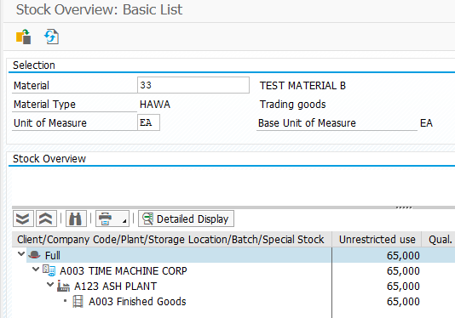

* STOCK IN PLANT A456 FOLLOWS:

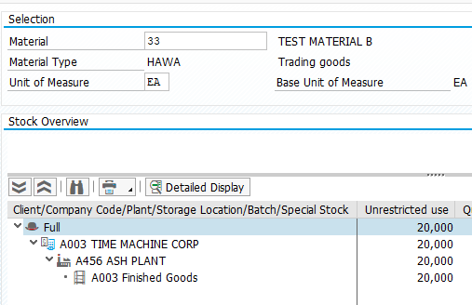

* CREATE STO ORDER USING T. CODE ME21N
* ENTER SUPPLYING PLANT, PURCHASING.ORG, PURCHASING GROUP, COMPANY CODE,

MATERIAL, PO QUANTITY TO BE TRANSFERRED, RECEIVING PLANT.

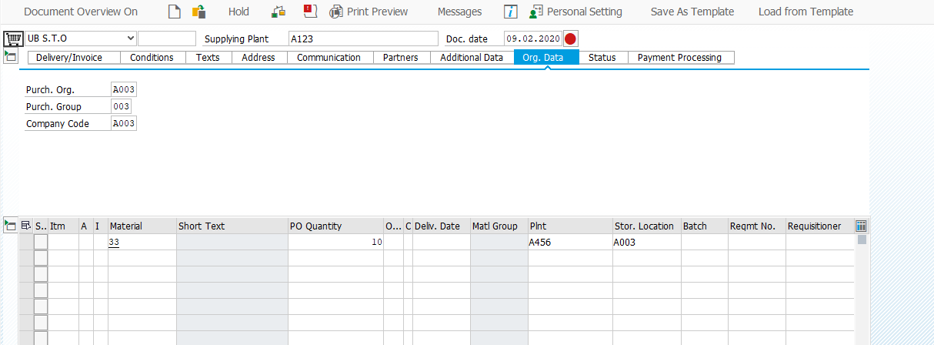

* GIVE ENTER IF ALL THE CONFIGURATION IS CORRECT YOU CAN SEE THE SHIPPING TAB

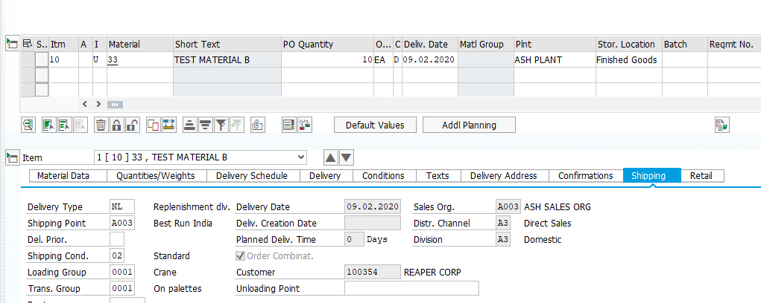

* HIT SAVE BUTTON AND YOUR STO ORDER IS CREATED WHICH IS 4500017763

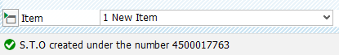

* HAVE TO CREATE DELIVERY USING T.CODE VL10B

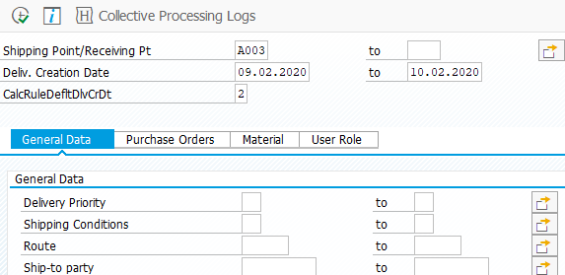

* HIT EXECUTE

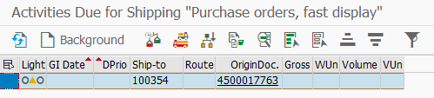

* AFTER SELECTING THE DOC RUN IT IN BACKGROUNG BY CLICKING IT

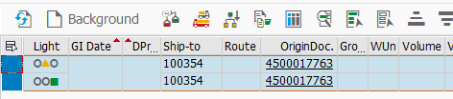

* THEN,CLICK HIDE AND SHOW DELIVERY ICON 

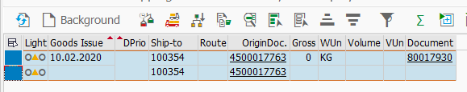

* USING DELIVERY DOCUMENT 80017930 HAS BEEN CREATED. THEN GO TO VL02N ENTER DOC NO THEN ENTER THE QTY TO BE TRANSFERRED IN PICKING QTY

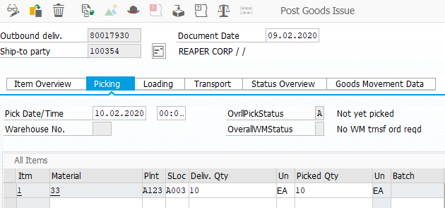

* GIVE ENTER AND POST GOODS ISSUE THEN OUTBOUND DELIVERY DOC NO: 80017930 WILL BE SAVED.
* NOW CHECK THE DOCUMENT FLOW USING T.CODE ME23N CAN BE VIEWED IN PO HISTORY

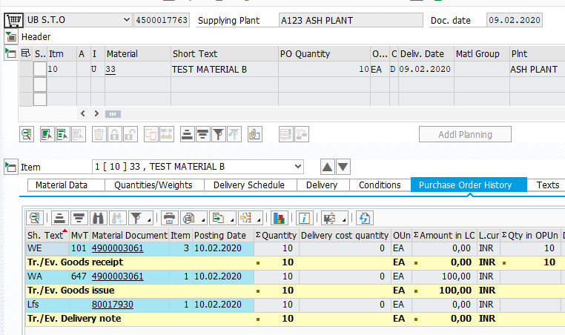

* MOVEMENT TYPE FOR ONE STEP IS 647
* IN ONE STEP PROCEDURE WE CAN SEE THE GOODS RECEIPT AND GOODS ISSUE
* NOW WE CAN SEE THE STOCK CHANGE AFTER TRANSFERRING THE STOCK IN STOCK OVERVIEW USING T.CODE MMBE
* STOCK IN SUPPLYING PLANT A123 REDUCED BY 10 QTY

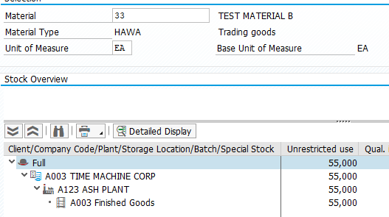

* ALSO STOCK IN RECEIVING PLANT A456 HAS BEEN INCREASED BY 10 QTY

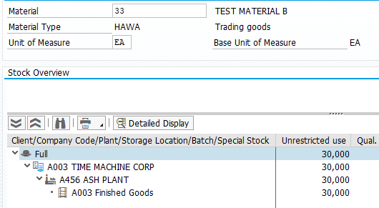

* TWO STEP PROCEDURE:
* FOR TWO STEP PROCEDURE WE HAVE TO UNSELECT THE ONE STEP BOX IN PATH SETUP STO – ASSIGN DOC TYPE, ONE STEP PROCEDURE AND SAVE IT.

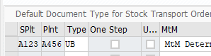

* CREATE A STO ORDER AS SAME AS STEPS FOLLOWED IN ONE STEP PROCEDURE USING TCODE ME21N,STO CREATED:4500017764
* CREATE DELIVERY USING VL10B:OUTBOUND DELIVERY CREATED:80017931
* CHECK DOCUMENT FLOW USING ME23N

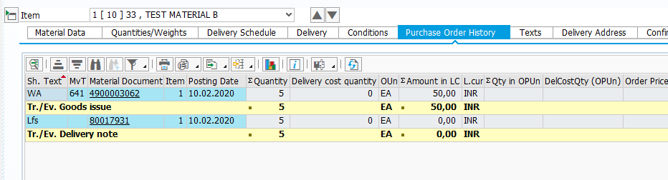

* TWO STEP PROCEDURE HAS MOVEMENT TYPE 641
* IT HAS ONLY GOODS ISSUE